|  |
| --- |
| Date/Location |
| 03/10/2022 @Zoom, 9:30 – 10:30 AM |

|  |  |
| --- | --- |
| Attendees | |
| Client | MAVDEV |
| Karolina Rivera | Ammar Lokhandwala |
|  | Maria Frausto |
|  | Michael Gurch |
|  | Victoria Sheraden |
|  | Vivian Bui |

|  |
| --- |
| Meeting Agenda |

1. **Current Trello Board**

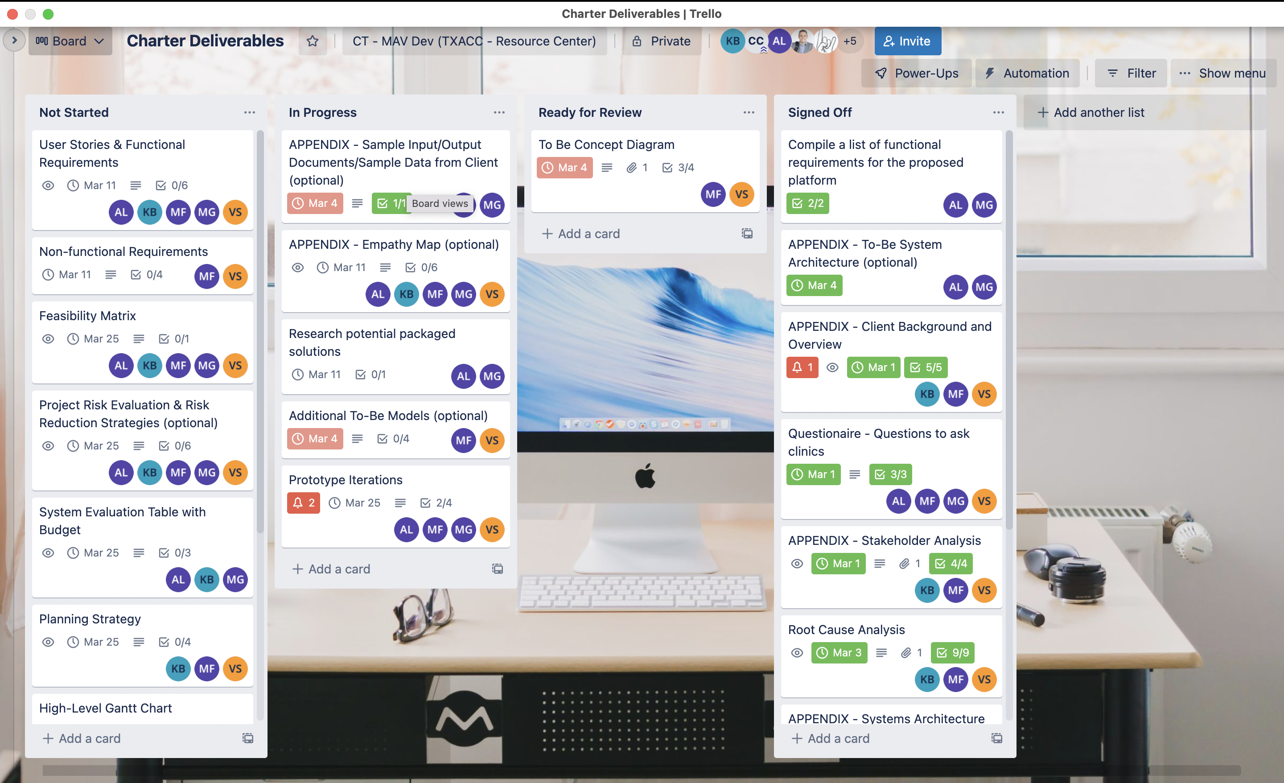

1. **Discussion Agenda**
2. Team Introduction
3. Q&A
4. Final Notes